TABLE OF CONTENT

1 GRAPH REPORT 3

2 TABLE REPORT 5

3 SETTINGS 7

4 BODY MEASUREMENT FORMULA 8

Body Mass Index (BMI) 8

Ideal weight (IW) 8

Waist to Hip Ratio (WHR) 8

Body Fat Percentage (BF%) 9

Lean Body Weight (LBW) 10

Basal Metabolic Rate (BMR) 11

Calories needs per day 11

Metabolic age 11

Help/Info 11

Calculate age from date of birth 12

Color definition 12

GRAPHIC WEB DESIGN



sadfasf

#### FEATURE 02: Body Measurement

When the user selects the **Body Measurement feature icon**, they will

be directed to the **Body Measurement page**.

On the Body Measurements page,

the system will display a

**Graph and a**

**Table button**

so that the user can view their information in graph, or table, format.

# GRAPH REPORT

Under the Graph button, there will be a **body measurement table** with several

body measurement categories; such as

**body mass index (BMI),**

**waist-to-hip ratio (WHR),**

**basal metabolic rate (BMR),**

**body fat percentage (bf%),**

**ideal weight, and**

**metabolic age.**

*XEM MỤC 4. Please refer to the formula document for more detail on any parameters, or measures, listed in this section.*

**TRỤC Y:**

|  |  |
| --- | --- |
| **body mass index (BMI),** | It is important to note that body mass index measures body fat, based on height and weight, for males and females. |
| **waist-to-hip ratio (WHR),** | Waist-to-hip ratio measures the circumference of the one's waist to their hips. |
| **basal metabolic rate (BMR),** | Also, basal metabolic rate is the amount of energy (i.e. calories) expended by someone at rest. |
| **body fat percentage (bf%),** | Body fat percentage is a measure of the total mass of one's fat divided by their total body mass |
| **ideal weight, and** | Finally, ideal weight suggests what a person of a given height and body frame should weigh |
| **metabolic age.** | metabolic age refers to a number that is calculated by comparing your basal metabolic rate to the basal metabolic rate average of your chronological age group |

**GRAPHIC BÊN TRONG:**

On the Body Measurement graph, if there is no information to display, then a

**notification** will state

***"You have no data to graph."***

Also, the graph's **fields** will be **color** coded to represent **different health levels for body measurement**.

For instance (ví dụ),

green is healthy,

yellow is under/overweight, and

orange is obese.

**TRỤC X:**

Under the Body Measurement graph, there will be a **date/time section** that the user can select.

If the user selects the date/time section, then a

pop-up calendar will display for the user to **select** a start and end date/time.

# TABLE REPORT

Aside from a graph, the user can also choose to have their data displayed in table format.

**HEADERS**

With the table format, the user will see various body measurement categories; such as

|  |  |
| --- | --- |
| **body mass index (BMI),** |  |
| **waist-to-hip ratio (WHR),** |  |
| **basal metabolic rate (BMR),** |  |
| **body fat percentage (BF%),** |  |
| **lean body weight (LBW),** | lean body weight refers to subtracting one's body fat weight from their total bodyweight. |
| **percent muscle (%muscle),** | percent muscle is a measure that defines how much of a person's total mass is muscle mass |
| **ideal weight (IW),** |  |
| **metabolic age,** |  |
| **activity level,** | Activity Level is a function of the one's total energy expended in a day, divided by their Basal Metabolic Rate |
| **calorie needs.** | Calorie Needs refers to the calories that one needs to maintain a healthy weight. This is calculated by accounting for one's height, weight, age, and activity level |

**NHÓM GIÁ TRỊ TRONG TABLE**

On the Body Measurement table, the user will also see **two** sets of

Value and

Diagnosis columns.

In these columns, the system will display the values and diagnosis for each category of body measurement.

**DATE/TIME**

Furthermore, there will be a section for Date/Time;

which the user can **click on** and a pop-up calendar will display.

The user can then **select a start and end date/time**.

If there is no data available, then a **notification** will state

***"There is no data to display."***

**PHẦN DIAGNOSIS**

Below the graph/table section, the system will display a Diagnosis and Recommendations field.

Initially, the Diagnosis and Recommendations section will have a

**notification** that reads

***"This page displays your current medical issues and the date that they were noted in your medical record. Click on the issue name for more in-depth information on that particular issue."***

By following the notification directions, the user will be able to retrieve details about their current diagnosis and previous diagnoses.

It will also detail recommendations based on the diagnoses provided.

**PHẦN BUTTTONS**

Beneath Diagnosis and Recommendations, there will be a Settings button and a Back to Track My Health button. If the user selects the Settings button, they will be directed to the Body Measurement Settings page. However, if the user selects the Back to Track My Health button, then they will be transferred to the Track My Health home page.

# SETTINGS

On the Body Measurement Settings page, the system will display

a **notification**, under the Body Measurement Settings sub-header, that states

***"This page displays the current settings of this feature."***

Below the notification, the user will have the **ability to change** via a drop-down list.

|  |  |
| --- | --- |
| Ideal Weight (IW) method | formula or medical. |
| Body Fat Percentage calculation method | Deurenberg, CUN-BAE, or U.S Navy |
| Body Fat Percentage evaluation method | WHO, Tanita, or Brainy |
| method to measure their Basal Metabolic Rate | Katch-McArdle, or Muffin |
| Activity Factor | based on their activity level  The user will make these changes by selecting a particular method via a drop-down list |

Under the body measurement methods section, the system will display

separate fields for

**Weight,**

**Height,**

**Waist,**

**Hip, and**

**Neck.**

The user will need to **accurately enter** their information for these fields so that the Body Measurement feature can track and function appropriately.

**BUTTONS**

Below this information, the user will see BUTTONS:

|  |  |
| --- | --- |
| Edit | If the user chooses to edit their settings, they will need to select the Edit button and make the desired changes. |
| Cancel | Once the changes are made, the user will select the Save button so that the desired settings are saved. |
| Save | However, if the user wants to cancel any changes, then they will select the Cancel button and no changes will be saved |
| Back | The user can also choose to select the Back button. This will take them back to the **Body Measurement page** |

# BODY MEASUREMENT FORMULA

### Body Mass Index (BMI)

Body Mass Index (BMI):a measure for human body shape based on an individual's weight and height

BMI = weight[kg] / (height[m])^2

BMI = (weight[lb] / (height[in])^2) x 703.06957964

|  |  |  |
| --- | --- | --- |
| BMI | Diagnose | Health risk |
| BMI < 16 | Severely underweight | Risk of developing problems such as nutritional deficiency and osteoporosis |
| 16 <= BMI <18.5 | Underweight | Risk of developing problems such as nutritional deficiency and osteoporosis |
| 18.5 <= BMI <25 | Normal | Low Risk |
| 25 <= BMI < 30 | Overweight | Moderate risk of developing heart disease, high blood pressure, stroke, diabetes |
| 30<= BMI < 35 | Obese | High risk of developing heart disease, high blood pressure, stroke, diabetes |
| BMI > 35 | Very Obese | High risk of developing heart disease, high blood pressure, stroke, diabetes |

### Ideal weight (IW)

* Calculate idea weight based on formula:

[Devine74]Men: Ideal Body Weight (in kg) = 50 kg + 2.3 kg per inch over 5 feet.

[Robinson83]Women: Ideal Body Weight (in kg) = 49 kg + 1.7 kg for each inch over 5 feet

* Calculate idea weight based on medical recommendation (BMI = 19-25):

weight[lb] = BMI / (height[in])^2 / 703.06957946

weight[kg] = BMI / (height[m])^2

* Evaluate current weight with ideal weight: based on s = (current weight – ideal weight)

If s > 0: “Your current weight excesses ideal weight s kg/lb”

If s < 0: “Your current weight is under ideal weight s kg/lb”

If s = 0: “You have perfect weight”

### Waist to Hip Ratio (WHR)

The WHR has been used as an indicator or measure of the health of a person, and the risk of developing serious health conditions.WHR is used as a measurement of obesity, which in turn is a possible indicator of other more serious health conditions.

Waist: Inches at NARROWEST point (NOTE: Measure one inch above navel).

Hip: Inches at WIDEST point.

WHR = waist/hip

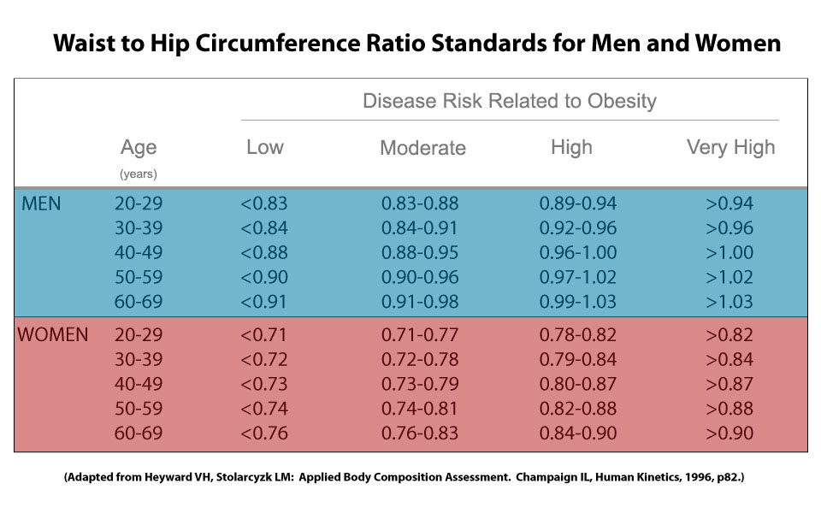

|  |  |  |
| --- | --- | --- |
| Gender | WHR | Abdominal Obesity |
| Male | < 0.9 | No |
|  | >= 0.9 | Yes |
| Female | < 0.85 | No |
|  | >= 0.85 | Yes |

### Body Fat Percentage (BF%)

The body fat percentage of a person is the total weight of fat divided by total weight; body fat includes essential body fat and storage body fat. Essential body fat is necessary to maintain life and reproductive functions. The percentage of essential body fat for women is greater than that for men, due to the demands of childbearing and other hormonal functions. The percentage of essential fat is 2 - 5% in men, and 10 - 13% in women[ACE (2009) ]

* Calculate BF% method 1 : based on BMI [Deurenberg]fomular 2

BF % = (1.29 x BMI) + (0.20 x Age) - (11.4 x gender) - 8.0

where gender is 1 for male and 0 for female

* Calculate BF% method 2 : CUN-BAE [Gómez-Ambrosi12]

BF% = –44.988 + (0.503 x age) + (10.689 x sex) + (3.172 x BMI)

– (0.026 x BMI^2) + (0.181 x BMI x sex) – (0.02 x BMI x age)

– (0.005 x BMI^2 x sex) + (0.00021 x BMI^2 x age)

where male = 0 and female = 1 for sex, and age in years,

* Calculate BF% method 3 : US Navy

Men:

BF% = (86.01 x LOG10((waist) - (neck))) - (70.041 x LOG10(height)) + 36.76

Women:

BF% = (163.205 x LOG10((waist) + (hip) - (neck))) - (97.684 x LOG10(height)) - 78.387

where waist, neck, height are measured in inches.

* Evaluate based on WHO

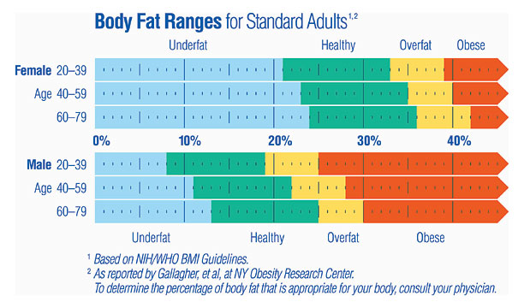

* Evaluate based on Tanita chart

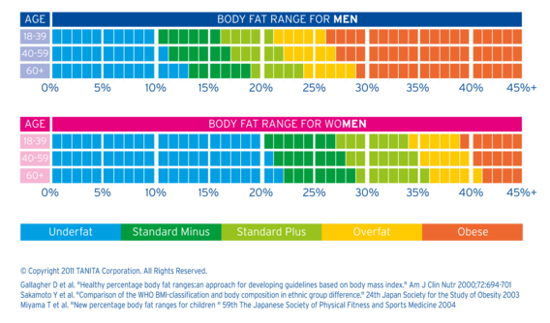

* Evaluate based on Brainy chart

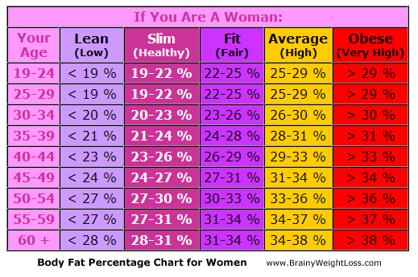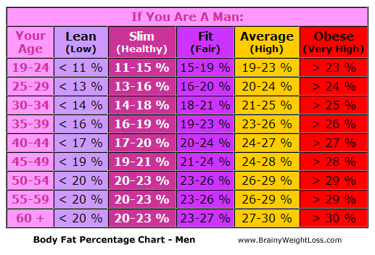

### Lean Body Weight (LBW)

Lean Body Weight refers to the sum of the weight of your bones, muscles and organs... basically the sum of everything other than fat in your body. The formula for lean body mass using the method of James1,2 is

Men: LBW = (1.10 x Weight(kg)) - 128 x( Weight(kg)^2/(100 x Height(m))^2)

Women:LBW = (1.07 x Weight(kg)) - 148 x( Weight(kg)^2/(100 x Height(m))^2)

### Basal Metabolic Rate (BMR)

Basal metabolic rate (BMR), and the closely related resting metabolic rate (RMR), is the amount of [energy](http://en.wikipedia.org/wiki/Food_energy) expended daily by humans and other animals at rest.

Basal Metabolic Rate is synonymous with Basal Energy Expenditure or BEE. BMR measurements are typically taken in a darkened room upon waking after 8 hours of sleep; 12 hours of fasting to ensure that the digestive system is inactive; and with the subject resting in a reclining position.

RMR stands for Resting Metabolic Rate, and is synonymous with Resting Energy Expenditure or REE. RMR measurements are typically taken under less restricted conditions than BMR, and do not require that the subject spend the night sleeping in the test facility prior to testing.

* Calculate BMR/RMR method 1 (Mifflin)

For men:

BMR = 5 + (10 x weight in kg) + (6.25 x height in cm) – (5.0 x age in years)

For women:

BMR = -161 + (10 x weight in kg) + (6.25 x height in cm) – (5.0 x age in years)

* Calculate BMR/RMR method 2 (Katch-McArdle)

BMR = 370 + 21.6 x LBM

where LBM in kg

* Evaluate BMR: TBD

### Calories needs per day

As BMR and RMR only represent resting energy expenditure, an adjustment must be made to reflect your activity level. This is done by multiplying your BMR or RMR by an activity factor (McArdle et al 1996). Note that the following activity factors also take into account The Thermic Effect of Food:

|  |  |  |
| --- | --- | --- |
| Activity Factor | Category | Definition |
| 1.2 | Sedentary | Little or no exercise and desk job |
| 1.375 | Lightly Active | Light exercise or sports 1-3 days a week |
| 1.55 | Moderately Active | Moderate exercise or sports 3-5 days a week |
| 1.725 | Very Active | Hard exercise or sports 6-7 days a week |
| 1.9 | Extremely Active | Hard daily exercise or sports and physical job |

* Calculate Calories needs per day

calories_needs = BMR * activity_factor;

### Metabolic age

Metabolic Age refers to a number calculated by comparing your Basal Metabolic Rate to the Basal Metabolic Rate average of your chronological age group [Wiki]

* Calculate metabolic age

diff_weight = weight – ieal_weight;

metabolic_age = age - 0.143 * (abs(diff_weight))^(1/3) + 0.236 * diff_weight;

* Evaluate Metabolic age: based on t = (current age – metabolic age)

If t > 0: “You are younger than your real age t years”

If t < 0: “You are older than your real age t years”

If t = 0: “Your real age is the same as your metabolic age”

### Help/Info

Display explanations of body measurement parameters, formulae except metabolic age formula.

Display guides how to measure waist, hip, neck.

### Calculate age from date of birth

Calculating age using sql server function: check the following functions

DATEDIFF(day,DOB,GETDATE())/365.242199

FLOOR(DATEDIFF(day,DOB,GETDATE())/365.242199)

### Color definition

#### BMI

|  |  |
| --- | --- |
| Evaluation | Color |
| Severely underweight | Blue |
| Underweight | Light Blue |
| Normal | Green |
| Overweight | Yellow |
| Obese | Orange |
| Very Obese | Red |

#### WHR

|  |  |
| --- | --- |
| Evaluation | Color |
| Low | Green |
| Moderate | Yellow |
| High | Orange |
| Very high | Red |

#### BF% - WHO

|  |  |
| --- | --- |
| Evaluation | Color |
| Underfat | Light Blue |
| Healthy | Green |
| Overfat | Orange |
| Obese | Red |

#### BF% - Tanita chart

|  |  |
| --- | --- |
| Evaluation | Color |
| Underfat | Light Blue |
| Standard minus | Green |
| Standard plus | Yellow |
| Overfat | Orange |
| Obese | Red |

#### BF% - Brainy chart

|  |  |
| --- | --- |
| Evaluation | Color |
| Lean (Low) | Light Blue |
| Slim (Healthy) | Green |
| Fit (Fair) | Yellow |
| Average (High) | Orange |
| Obese (Very High) | Red |